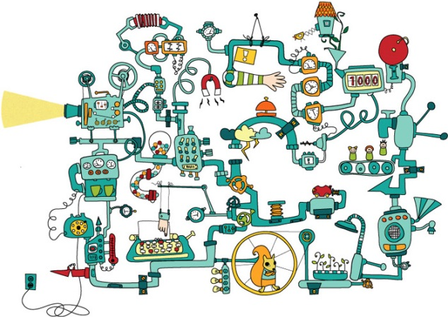
Plan out an idea to share with your group.
Your contraption will have to include at least 8 different stages and be able to lift a load.

