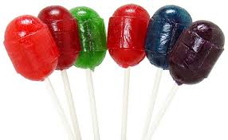
Name___________________________________________ Date____________________
Blow Pop Inquiry Lab
Topic: Scientific Method
Question: How many licks does it take to get to the center of a Blow Pop?
Research: Make a list of all the things you KNOW about Blow Pops, licking suckers, tongues, saliva, candy in general, etc.
Hypothesis: I think the lollipop that is _______________________________ will get to the center of the lollipop the quickest.

Materials: (Be sure to include EVERYTHING!)
___________________________________________________________________________________________________________________________________________________________________________________________________________________________________________________________________________________________________________________________________________________________________________________________________________________________________________________________________________________
Procedure: (Make sure the steps are in order and don’t leave ANYTHING out!)
________________________________________________________________________________________________________________________________________________________________________________________________________________________________________________________________________________________________________________________

Observations: (during the experiment)
 | 1 min | 2 min | 3 min | 4 min | 5 min | 6 min | 7 min | 8 min
Lollipop one

Lollipop two

Lollipop three

Lollipop four

Lollipop five

Analysis/Conclusions:
________________________________________________________________________________________________________________________________________________________________________________________________________________________________________________________________________________________________________________________

Why might different people get different results?
____________________________________________________________________________________________________________________________________________________________
What did you learn about the scientific method from this experiment?
____________________________________________________________________________________________________________________________________________________________
______________________________________________________________________________

